## STUDENT NAME: ***YASH GUPTA*** UID: ***20BCS5009*** BRANCH: ***B.E CSE*** SECTION/GROUP: ***CSE 34/B***

# AIM:

Design a data acquisition system using multiplexer.

# TASK TO BE DONE:

In this experiment, we will be learn about Multiplexer. Also, learn how Multiplexer works and by how varying the select lines the different Inputs comes at the outputs.

# Requirements:

**MC14052B** IC, Resistances (470ohms, 1K ohms, 1.5 k ohms, 2.2 k ohms), 5V Power Supply, Breadboard, Connecting wires.

# Circuit diagram/ Block diagram:

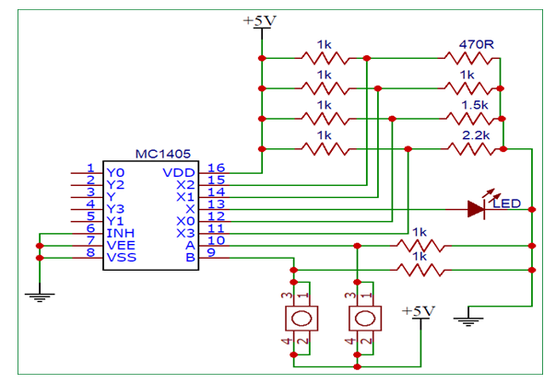

# Simulating **Results:**

***When simulation is not started yet.***

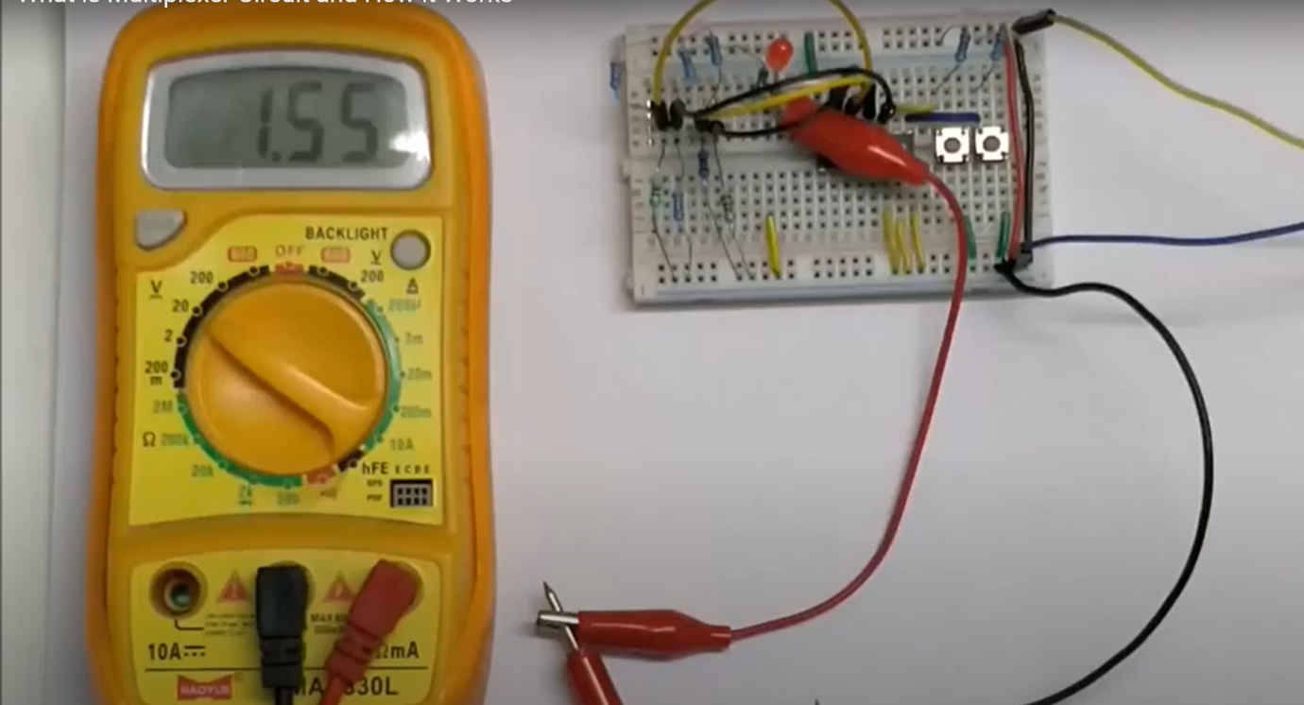

***When simulation has started.***

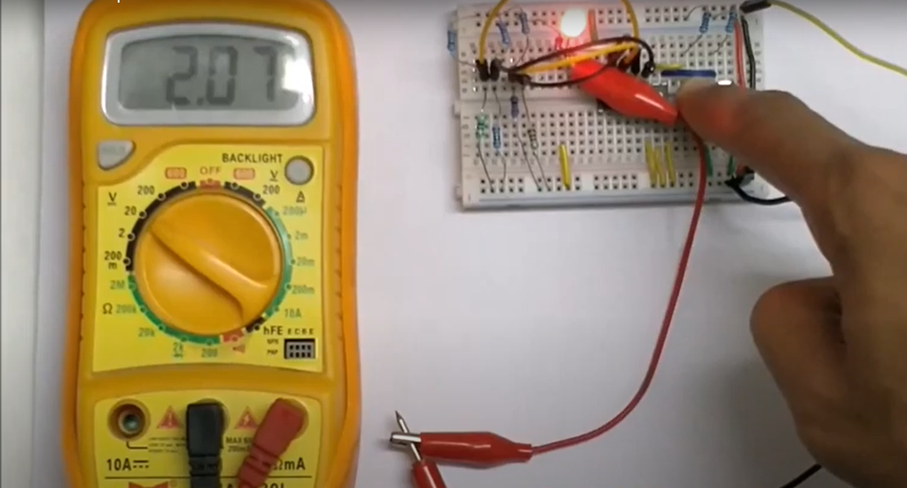

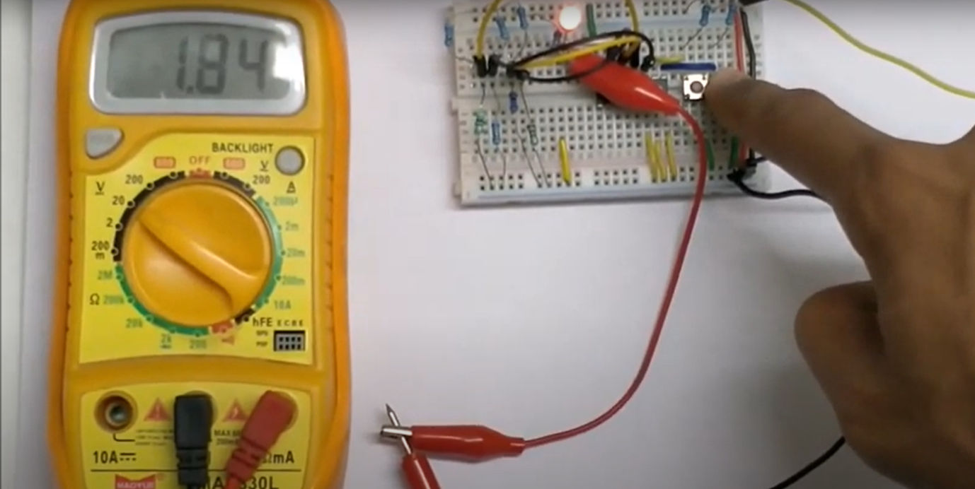

# CONCEPT USED:

A DAQ system consists of sensors, DAQ measurement hardware and a computer with programmable software. Compared to traditional measurement systems, PC-based DAQ

systems exploit the processing power, productivity, display, and connectivity capabilities of industry-standard computers providing a more powerful, flexible, and cost-effective measurement solution.

# Learning/Observation:

The MC14052 is an Analog Multiplexer meaning the input pins can also be supplied with variable voltage and the same can be obtained though the output pins. The IC outputs variable input voltage based in the control signals provided.

# Troubleshooting:

The Vdd pin has not connected to the supply voltage. So,

the Vdd pin (pin 16) has to connect to the supply voltage which is +5V and the Vss and Vee pin should be grounded. The Vee pin is for enable which is an active low pin so we have to ground it to enable this IC.